Contents

**No table of contents entries found.**

---------------------------------------------------------------

# Issue Number: example

**Issue Title:**

**Date:**

**Issue Reporter:**

**Issue Description:**

**Steps Taken to Resolve Issue:**

**Final Resolve Date - if applicable:**

--------------------------------------------------------------

---------------------------------------------------------------

# Issue Number: 1

**Issue Title: Loss of USB and Data**

**Date: 10/10/2017**

**Issue Reporter: Jamie Kostaschuk**

**Issue Description:**

The USB (including the user-specific map pages) that we worked on in the last meeting (week 11 tutorial) was left in the classroom. And cannot be found.

This means that I will be making up for the lost work this week, instead of progressing further with other aspects.

**Steps Taken to Resolve Issue:**

* Lost property claim with QUT has been lodged
* The aspects that need to be worked on have been noted (in this documentation and by me)
* Team has been informed, and no additional workload has been assigned to Jamie to avoid overworking/unbalanced workload for the week.

**Final Resolve Date - if applicable: 14/10/2017**

* The lost features have been re-created again by Jamie, and work will continue again

--------------------------------------------------------------

---------------------------------------------------------------

# Issue Number: 2

**Issue Title: bug in map features**

**Date: 14/10/2017**

**Issue Reporter: Jamie Kostaschuk**

**Issue Description:**

With the checkboxes, certain combinations of locations/aspects restrict the results, or produce no results in the map at all.

It is believed that this is because of the way in which the website searches google maps through the weblink API that is supplied by google. And if we change how we search in that link, we can solve the problem.

An example is below, where searching for Zoos and Universities in Brisbane produce no results.

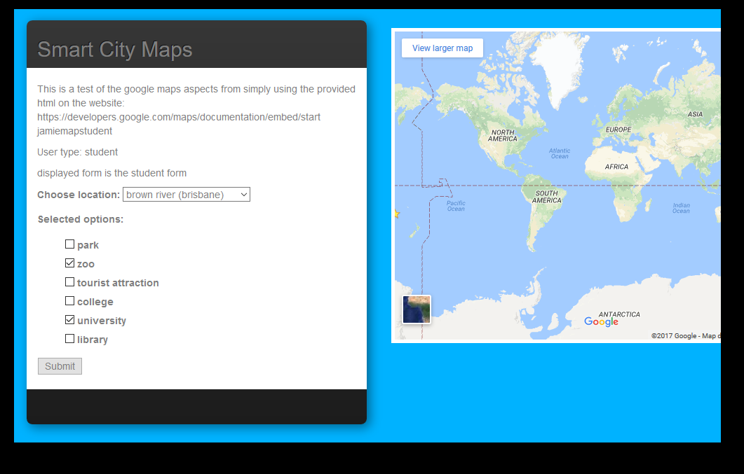

**Steps Taken to Resolve Issue:**

* Entire team has been updated of the problem
* Proper analysis of potential cause has been identified and documented in this review
* Team will aim to tackle the problem in the near future

**Final Resolve Date: if applicable: 22/10/2017**

* Jamie has edited the codesnippets.py’s function “get_google_url”

--------------------------------------------------------------